Vijay’s Assignment 1

1. Start Hadoop single node on AcadGild VM. The command is start-all.sh.
   1. After opening the terminal in VM, I entered few Unix commands like ls to list all the directories and files in my current location, pwd to check my current working directory
   2. Entered “start-all.sh” to start the Hadoop single node service

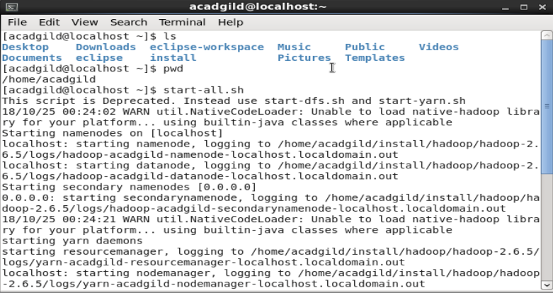

1. Run a JPS command to see if all Hadoop daemons are running.
2. Run few Unix commands like pwd, ls -ls, etc.
3. Create a file from the terminal using nano editor (example: nano test.txt), and add some content in it. Cat it to see if the content is saved.
   1. Executed “jps” command to display the daemons running in my VM
   2. Executed few unix commands once again
   3. Using nano editor created a file “test.txt” and entered the text “this is a test by vijay” and saved it by using CtrlX and save.
   4. Displayed the file using “cat” command

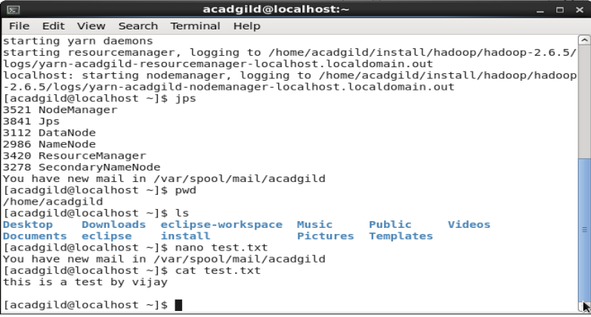

1. Open the hdfs web page by typing localhost:50070 in the browser. Check all the details of HDFS

